Carlsbad Rental Housing Update August 2018

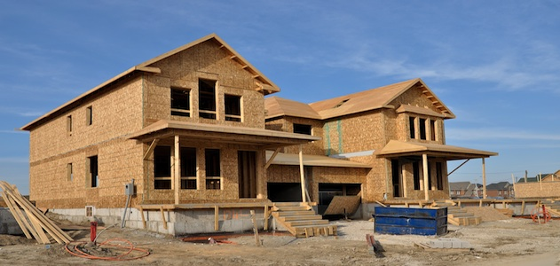

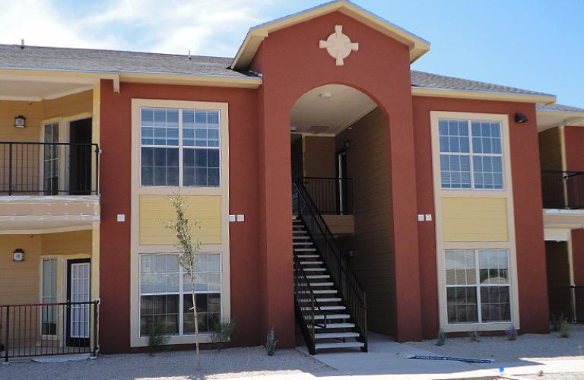

1. ***Residential Living Availability and Affordability***

The table below displays the occupancy rates of apartments in Carlsbad over the past year and a half. As of August 2018, the rate of occupancy for all apartments in the area sits at 100%. Many complexes have begun a waiting list for people looking for a place to live and all combined there are over 430 people waiting for apartments.

**Table 1. Occupancy Rates for Apartments in Carlsbad 2017-2018**

Source: Carlsbad Department of Development

**Table 2. Waiting Lists for Apartments in Carlsbad, August 2018**

|  |  |
| --- | --- |
| **Apartments** | **# on List** |
| Avalon Apartments | 150 |
| Cielo Vista Apartments | 100 |
| Copperstone | 120 |
| The Village | 35 |
| Vista Del Rio | 25 |
| **Total Waitlist:** | **430** |

Source: Carlsbad Department of Development

After surveying the current pricing of local market rate units in early August, the three newest complexes had rental prices that ranged from $900-$1,750, which is up about on average 11.3% since May of 2017. The table below shows the pricing of market rate apartments in the area over the past three years.

**Table 3. Cost of Market Rate Apartments in Carlsbad 2016-2018**



Source: Carlsbad Department of Development

Due to the influx of workforce using hotels as a temporary residence, many of which have monthly rates due to companies renting blocks of hotels, we have seen a severe increase in nightly hotel room rates. They are up on average 54% since August of 2017. The table below shows the pricing of market rate apartments in the area over the past year.

**Table 4. Hotel Nightly Rates in Carlsbad 2017-2018**

|  |  |  |  |  |
| --- | --- | --- | --- | --- |
| **Hotel** | **# of Units** | **Aug-18** | **Dec-17** | **Aug-17** |
| Stevens Inn | 205 | $120 | $162 | $156 |
| Candlewood Suites | 81 | $369 | $258 | $210 |
| Carlsbad Inn | 30 | $150 | $130 | $120 |
| Caverns Motel of Carlsbad | 46 | $85 | $93 | $90 |
| Caverns Inn |  | $69 | $99 |  |
| Comfort Inn & Suites | 87 | $279 | $199 | $209 |
| Continental Inn | 60 | - | - | $80 |
| Days Inn | 60 | $184 | $194 | $139 |
| Econo Lodge | 124 | $159 | $109 | $79 |
| Economy Inn | 24 | $100 | $87 | $74 |
| El Rey Motel | 20 | $275 | $112 | $70 |
| Executive Suites & Hotel | 90 | $100 | $96 | $69 |
| Fairfield Inn by Marriott | 91 | $354 | $299 | $229 |
| Fiddler's Inn Bed & Breakfast | 3 | $196 | $269 | $170 |
| Great Western Inn & Suites | 84 | $130 | $110 | $75 |
| Hampton Inn | 84 | $384 | $289 | $309 |
| Holiday Inn Express | 80 | $405 | $314 | $171 |
| La Fonda Motel | 14 | $85 | $122 |  |
| La Quinta | 96 | $249 | $334 | $214 |
| Motel 6 | 73 | $136 | $84 | $90 |
| Motor Lodge | 50 | - | $112 |  |
| Parkview Motel | 30 | - | $97 | $89 |
| Rodeway Inn/White's City | 60 | $120 | $100 | $109 |
| Royal Manor | 26 | $389 | $130 | $80 |
| Sleep Inn | 75 | $269 | $209 | $209 |
| Stagecoach Inn | 60 | - | $110 | $90 |
| Super 8 Motel | 56 | $201 | $150 | $106 |
| Towneplace Suites | 94 | $289 | $329 | $349 |
| Trinity Hotel | 9 | $209 | $370 | $189 |
| U.S. Travelers Inn & Suites | 53 | $203 | $143 | $100 |
| **Total Hotel Rooms:** | **1865** |  |  |  |

***Additional Rentals***

In addition to multi-family units and houses, there are three other sources of rental residences: mobile home and RV parks, hotel and motel rooms that are leased for longer stay, and so-called “man camps” or temporary RV parks.

Permanent RV and Mobile home parks are listed in the following chart. All available spaces were filled, based on telephone interviews with those willing to release information. These parks do not include temporary mobile home/RV areas. These facilities are more difficult to track in the unincorporated part of the county as there is no zoning and they are not required to have permits from the County to operate.

**Table 5. Mobile Homes and Recreational Vehicle Parks Around Carlsbad, NM**

|  |  |  |  |  |
| --- | --- | --- | --- | --- |
| **RV PARK** | **# SPACES** |  | **Aug-18** | **Feb-17** |
| **AOK RV Retreat** | 86 | occupancy rate | 90% | 20% |
| (877) 625-6626 |  | weekday rate | $160 weekly | $30 |
| 2700 E. Greene St, Carlsbad |  | monthly rate | $550 | $450 |
| **Bonaventure Boyd Mobile Home Park** | 42 | occupancy rate |  |  |
| (408) 689-1575 |  | weekday rate |  | $225 |
| 1901 Boyd Dr., Carlsbad |  | monthly rate |  | $500 |
| **Bud's Place RV Park** | 47 | occupancy rate |  | 90% |
| (575) 200-1865 |  | weekday rate |  | $30 |
| 900 Standpipe Rd, Carlsbad |  | monthly rate |  | $450 |
| **Carlsbad KOA** | 150 | occupancy rate |  | 75% |
| (575) 457-2000 |  | weekday rate |  | $303 |
| 2 Manthei Rd, Carlsbad |  | monthly rate |  | $650 + electric |
| **Carlsbad Manor** | 61 | occupancy rate |  | 90% |
| (575) 200-1865 |  | weekday rate |  |  |
| 111 Ferris, Carlsbad |  | monthly rate |  | $325 |
| **Carlsbad RV Park & Campground** | ~80 | occupancy rate |  | 98% |
| (575) 885-6333 |  | weekday rate | $38-$45 | $37-$42 |
| 4301 National Parks Hwy, Carlsbad |  | monthly rate | $650-$750 | $500-$750 |
| **Custom Touch Village** | 60 | occupancy rate | 98% | 50% |
| (575) 361-5022 |  | weekday rate |  | $80 |
| 4230 Boyd Dr, Carlsbad |  | monthly rate | $1,450 | $1,700 |
| **El Dorado Estate Mobile Home & RV Park** | 98 | occupancy rate |  | 95% |
| (575) 887-3111 |  | weekday rate |  |  |
| 3022 National Parks Hwy, Carlsbad |  | monthly rate |  | $550 |
| **RV PARK** | **# SPACES** |  | **Aug-18** | **Feb-17** |
| **Ironhorse Man Ranch** | 270 | occupancy rate |  | 75% |
| (832) 314-8816 |  | weekday rate |  |  |
| 127 Carlgo St, Carlsbad |  | monthly rate |  | $600 |
| **Keystone Mobile Home, 55+** | 33 | occupancy rate | 100% | 100% |
| (575) 885-2855 |  | weekday rate |  |  |
| 1315 E. Orchard Ln., Carlsbad |  | monthly rate | $410 | $400 |
| **North Star RV Park** | 43 | occupancy rate | 100% | 100% |
| (575) 361-3303 |  | weekday rate |  |  |
| 2519 Pecos Hwy, Carlsbad |  | monthly rate | $700 | $550 |
| **Park Place Mobile Home Park** | 27 | occupancy rate | 100% | 100% |
| (575) 887-0909 |  | weekday rate |  |  |
| 1010 Center Ave., Carlsbad |  | monthly rate | $125 | $125 |
| **Pecos River RV Park** | 16 | occupancy rate |  | 90% |
| (575) 887-9835 |  | weekday rate |  | $50 |
| 320 E. Greene St., Carlsbad |  | monthly rate |  | 650 |
| **Southwest RV and Trailer Park** |  | occupancy rate | 100% |  |
| (575) 361-1738 |  | weekday rate |  |  |
| 308 E Orchard Ln, Carlsbad |  | monthly rate |  |  |
| **Sun West Mobile City** | 257 | occupancy rate | 100% |  |
| (575) 885-1900 |  | weekday rate |  |  |
| 4219 Boyd Drive, Carlsbad |  | monthly rate | $750 all bills paid |  |
| **Sweetwater** | 35 | occupancy rate |  | 90% |
| (575) 885-2022 |  | weekday rate |  |  |
| 3401 National Parks, Carlsbad |  | monthly rate |  | $300 |
| **Westwind Mobile Home** | 70 | occupancy rate |  | 70% |
| (575) 887-9573 |  | weekday rate |  |  |
| 2412 Harding St., Carlsbad |  | monthly rate |  | $300-$500 |
| **White's City RV Park** | 40 | occupancy rate |  | 50% full |
| (575) 785-2291 |  | weekday rate |  | $40 |
| 17 Carlsbad Cavern Hwy, Whites City |  | monthly rate |  | $600 |
| **Windmill Park** | ~55 | occupancy rate |  | 86% |
| (575) 887-1387 |  | weekday rate | $38-$45 | $37-$42 |
| 3624 National Parks Hwy, Carlsbad |  | monthly rate | $650-$750 | $500-$750 |