Carlsbad Housing Report December 2017

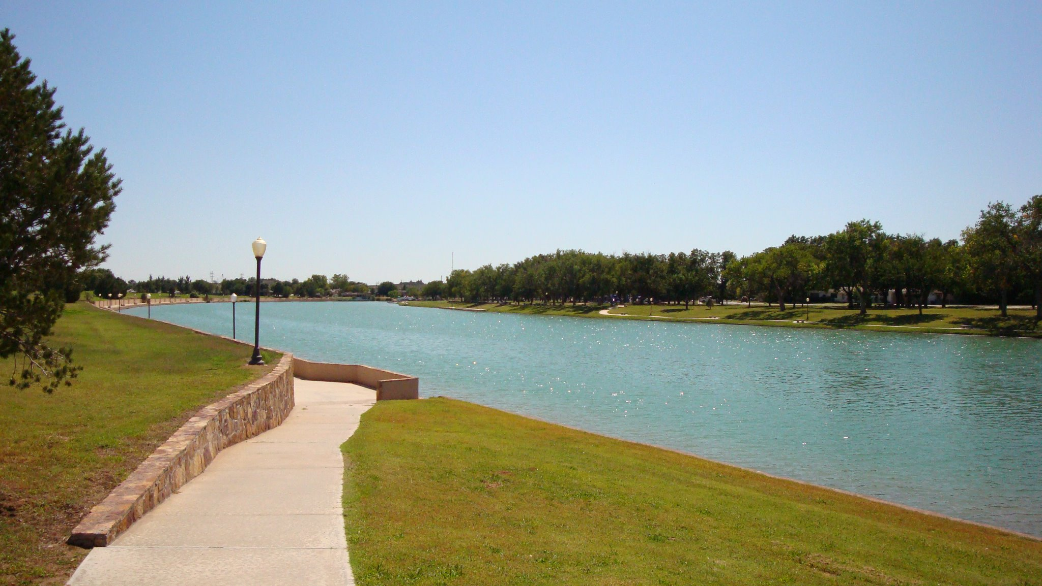

Table of Contents

I. Introduction.......................................................................................................................................... 2

II. Housing Availability and Affordability ................................................................................................. 4

III. Employer Housing Survey .................................................................................................................. 8

IV. Future Development ......................................................................................................................... 14

V. Conclusion .......................................................................................................................................... 17

1. ***Introduction***

Carlsbad and Eddy County are experiencing a housing shortage do to an influx of labor working in the oil and gas fields coupled with a diverse and thriving economy. During the current upswing in oil and gas that began in early 2017, we began seeing the same markers we saw from 2012-2015, natural resources employment in the county went up, residential occupancy rate began to rise, unemployment rates began to fall, and hotel and housing prices increased. This has created a surge in our population with the greater Carlsbad area population sitting at around 63,500, and people are living wherever they can find availability. According to the 2015 housing study, there are three main groups not being well served by the existing housing 1) households where the primary wage earner makes $10 per hour and below, 2) the general workforce earning between $10 and $16 an hour, and 3) households who can afford the market area prices but can’t find anything suitable to rent or buy. In addition, there are workers, primarily in the oil and gas related industries, who live in Eddy County during the week and return home on the weekends. These workers do not relocate their families because of the lack of housing. Eddy County is situated in the middle of a very large oil and gas play with unprecedented opportunity due to the major stratification of the layers.

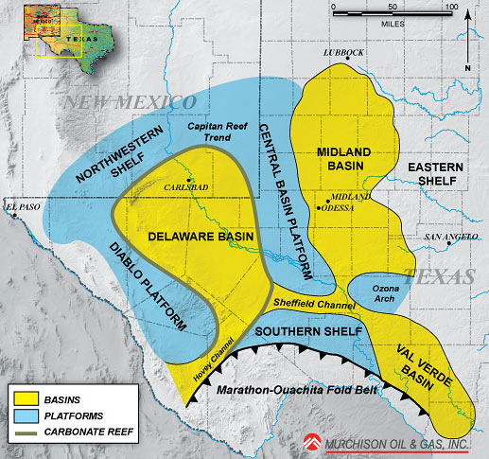

**Location of Carlsbad within Permian Energy Play (Graphic: Murchison Oil and Gas)**

With major oil and gas companies taking advantage of the resources in the Delaware Basin, many have indicated Eddy County’s future has a high probability of turning into a Midland/Odessa metropolis rather than continuing as a small town. Some of the city's recent oil and gas projects include a natural gas plant connected to Texas-based companies - Summit Midstream Partners LP, XTO Energy Inc., a subsidiary of Exxon Mobil Corp. which is connected to Summit's new natural gas gathering and processing system in the Permian. The Current-Argus reported in September 2017 that Summit is anticipating up to $500 million in future investments in the Northern Delaware Basin. 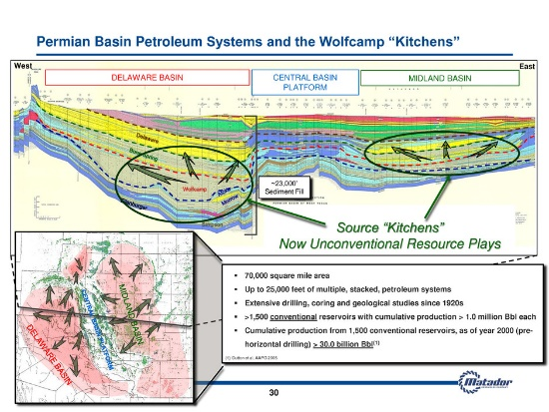

**Cross Section of Delaware vs. Permian (Graphic: Matador Services)**

Even prior to the rise in oil and gas, Carlsbad has relied on many other industries to maintain strong economic growth in the area. Two potash mines have been long standing employers of the community, a strong nuclear industry with the Department of Energy Nuclear Waste Repository (WIPP) facility employs over 1200 people, a growing manufacturing industry, and has always been able to rely on tourism thanks to the natural formation of the Carlsbad Caverns, which receives more than 500,000 visitors annually. The expectation is that the industries are here to stay and will need housing and services for the additional employees they intend to hire.

1. ***Housing Availability and Affordability***

The table below displays the occupancy rates of apartments in Carlsbad over the past year. As of September, the rate of occupancy for all apartments in the area sits at 100%. Many complexes have begun a waiting list for people looking for a place to live and all combined there were over 125 people waiting for apartments.

**Table 1. Occupancy Rates for Apartments in Carlsbad 2017**

|  |  |  |  |  |  |  |  |  |
| --- | --- | --- | --- | --- | --- | --- | --- | --- |
|  |  |  | **2017** | | | | | |
|  | **Apartment** | **# of Units** | **sep** | | **may** | | **jan** | |
|  |  | | **units available** | **occupancy rate** | **units available** | **occupancy rate** | **units available** | **occupancy rate** |
| 1 | Avalon Apartments | 112 |  | 100% | 28 | 75% | 30 | 73% |
| 2 | Colonial Hillcrest Apartments | 76 | 0 | 100% | 0 | 100% | 0 | 100% |
| 3 | Church Street Apartments | 21 |  | 100% | 2 | 90% | 4 | 81% |
| 4 | Cielo Vista Apartments | - | NA | - | NA | - | NA | - |
| 5 | Copper Ridge | 24 | 0 | 100% | 0 | 100% | 0 | 100% |
| 6 | Copperstone | 347 | 0 | 100% | 7 | 98% | 37 | 89% |
| 7 | La Posada | 12 |  | 100% | NA | - | 0 | 100% |
| 8 | Mesa Grande | 72 | 0 | 100% | 4 | 94% | NA | - |
| 9 | Sun Village | 11 |  | 100% | 0 | 100% | NA | - |
| 10 | Northbrook | 10 | 0 | 100% | 0 | 100% | NA | - |
| 11 | River Oak | 38 | 0 | 100% | 1 | 97% | NA | - |
| 12 | Riverwood | 50 | 0 | 100% | NA | - | 3 | 94% |
| 13 | SCS, LLC | 9 | 0 | 100% | 0 | 100% | 0 | 100% |
| 14 | The Village | 144 |  | 100% | 20 | 86% | 64 | 56% |
| 15 | Tia Maria | 40 | 1 | 98% | 1 | 98% | 1 | 98% |
| 16 | Vista Del Rio | 112 | 3 | 97% | 0 | 100% | 0 | 100% |
| 17 | Vista Del Sol | 48 | 1 | 98% | 0 | 100% | 0 | 100% |
| 18 | Mission Apartments | 68 |  | 100% | 0 | 100% | 0 | 100% |
| 19 | Yucca Flats | 34 | 0 | 100% | 1 | 97% | 2 | 94% |
|  | **Total Apartment Units:** | **1228** |  |  |  |  |  |  |

Source: Carlsbad Department of Development

After surveying the current pricing of local market rate units in early September, the three newest complexes had rental prices that ranged from $850-$1530, which is up about on average 10% since May of this year. The table below shows the pricing of the three major market rate apartments in the area over the past three years.

**Table 2. Cost of Market Rate Apartments in Carlsbad 2015-2017**

|  |  |  |  |  |  |
| --- | --- | --- | --- | --- | --- |
| **Apartments** | **2017** | | **2016** | | **2015** |
| Avalon | **(575) 885-3350** | | **1907 San Jose Blvd.** | | **est. 2011** |
|  | **sep** | **may** | **jul** | **mar** | **apr** |
| **1 bedroom (650 sq. ft.)** | 995 | 859 | 995 | 995 | 905 |
| **1 bedroom (725 sq. ft.)** | 995 | 899 | 995 | 995 | 945 |
| **2 bedroom (925 sq. ft.)** | 1,300 | 1,199 | 1,300 | 1,300 | 1,250 |
| **2 bedroom w/ study (1000 sq. ft.)** | 1,400 | 1,299 | 1,400 | 1,400 | 1,350 |
| **3 bedroom (1250 sq. ft.)** | 1,530 | 1,399 | 1,530 | 1,530 | 1,480 |
|  |  |  |  |  |  |
| Copperstone | **(575) 234-1637** | | **1101 Calloway Drive** | | **est. 2011** |
|  | **sep** | **may** | **jul** | **mar** | **apr** |
| **1 bedroom (669 sq. ft.)** | 880 | 850 | 850 | 850 | 800 |
| **1 bedroom (753 sq. ft.)** | 985 | 955 | 955 | 955 | 905 |
| **1 bedroom (739 sq. ft.)** | 980 | 950 | 950 | 950 | 900 |
| **2 bedroom (1038 sq. ft.)** | 1,245 | 1,215 | 1,215 | 1,215 | 1,125 |
| **2 bedroom (1078 sq. ft.)** | 1,270 | 1,240 | 1,240 | 1,240 | 1,150 |
| **2 bedroom (1157 sq. ft.)** | 1,395 | 1,345 | 1,255 | 1,255 | 1,345 |
| **2 bedroom (1246 sq. ft.)** | 1,365 | 1,315 | 1,345 | 1,345 | 1,315 |
| **2 bedroom (1225 sq. ft.)** | 1,355 | 1,305 | 1,315 | 1,315 | 1,305 |
| **3 bedroom (1190 sq. ft.)** | 1,390 | 1,360 | 1,360 | 1,360 | 1,240 |
| **3 bedroom (1424 sq. ft.)** | 1,500 | 1,450 | 1,450 | 1,450 | 1,450 |
|  |  |  |  |  |  |
| The Village Apartments | **(575) 628-0033** | | **3821 National Parks Hwy.** | | **est. 2012** |
|  | **sep** | **may** | **jul** | **mar** | **may** |
| **1 bedroom (671 sq. ft.)** | 850 | 850 | 975 | 975 | 950 |
| **2 bedroom (766 sq. ft.)** | 950 | 950 | 1,025 | 1,025 | 1,000 |
| **2 bedroom (901 sq. ft.)** | 1,075 | 1,075 | 1,175 | 1,175 | 1,150 |
| **2 bedroom (1001 sq. ft.)** | 1,150 | 1,150 | 1,200 | 1,200 | 1,175 |

Source: Carlsbad Department of Development

As table 3 below demonstrates, the median price of houses sold in Eddy County has risen steadily from $130,000 in 2010 to $165,000 in December 2017, despite the national recession and increase in housing units in the area.

**Table 3. Housing Units Sold in Eddy County 2010-2017**

|  |  |  |  |  |  |  |  |  |
| --- | --- | --- | --- | --- | --- | --- | --- | --- |
| *Year* | *2010* | *2011* | *2012* | *2013* | *2014* | *2015* | *2016* | *Dec. 2017 YTD* |
| Units Sold | 470 | 462 | 541 | 548 | 621 | 451 | 377 | 369 |
| % Change from previous year | 7.3% | (1.7%) | 17.1% | 1.3% | 13.3% | (27.4%) | (16.4%) | (2.1%) |
| Median Price | $130,000 | $138,000 | $140,000 | $145,000 | $160,000 | $169,000 | $160,000 | $165,000 |
| % Change from Previous Year | --- | 6.2% | 1.4% | 3.6% | 10.3% | 5.6% | (5.3%) | 3.1% |

Source: Realtors Association of New Mexico, 2017

Based on the City of Carlsbad building permit data, there is reason to believe that the number of residential units actually built may vary slightly from what the building permit data shows. For example, in 2016, a large building permit was pulled for a new apartment complex called Pecos Vista Apartments; however, the new proposed number of units the apartments will include is 196 units that was announced at a 2017 spring groundbreaking for the project.

**Table 4. Greater Carlsbad Area Building Permit Data 2010-2017**

|  |  |  |  |  |  |
| --- | --- | --- | --- | --- | --- |
| Year | Manufactured Housing/Mobile Homes | Total Single Family | No. of Apt Units | Duplex Units | Total Housing Units |
| 2010 | 23 | 76 | 0 | 0 | 99 |
| 2011 | 38 | 86 | 235 | 4 | 363 |
| 2012 | 12 | 97 | 268 | 0 | 377 |
| 2013 | 51 | 159 | 0 | 0 | 210 |
| 2014 | 42 | 149 | 256 | 12 | 459 |
| 2015 | 37 | 118 | 0 | 4 | 159 |
| 2016 | 22 | 82 | 204 | 0 | 308 |
| 2017 YTD | 34 | 107 | 0 | 0 | 141 |
| **Total** | 259 | 874 | 963 | 20 | **2,116** |

Source: City of Carlsbad Building Permit Data 2010-2017

Since 2009, two housing studies have been conducted on the needs for housing, one in 2009 and one in 2015. The projected need for housing is based on a healthy economy that will continue at a steady pace of growth.

**Table 5. Housing Units Needed According to Housing Studies**

|  |  |  |  |
| --- | --- | --- | --- |
|  | **Projected Need\*** | **Residential Building Permits Pulled\*\*** | **Deficit** |
| Eddy County Housing Units Needed 2010-2014 | 2,687-2,902 | 1,508 | 1,179-1,394 |
| Eddy County Housing Units Needed 2015-2020 | 5,961-6,286 | 608 | 5,353-5,678 |
| **Total Units Needed by 2020** | **8,648-9,188** | **2,116** | **6,532-7,072** |

Source:*Greater Carlsbad Housing Analysis & Strategic Plan, Sites Southwest, 2009; City of Carlsbad Housing Analysis and Strategic Plan Update, Sites Southwest, 2015. **City of Carlsbad Building Permit Data 2010-2017

1. ***Employer Housing Survey***

The Carlsbad Department of Development conducted surveys of Carlsbad area employers to identify housing needs and community housing concerns. Between the months of August through October, 39 employers completed surveys. The survey asked a number of questions about current housing conditions, affordability, and availability.

Thirty-nine employers representing a range of business types and sizes responded to the survey. These businesses together had a total of 3,896 employees.

1. **Type of Business**

The employers who responded to the survey represent a variety of industry categories. The highest percentages were 20.5 percent in mining/oil & gas, and 12.8 percent in government. The third and fourth highest percent—10.3 percent each were in construction and banking/finance/insurance. The rest were spread among education, manufacturing, transportation/communication/utilities, health care services, retail trade/sales, real estate/property management, hotels/motels/lodging, business services, engineering/architecture, and non-governmental social services. In the “other” category were non-profits and news/media.

|  |  |  |
| --- | --- | --- |
| Business Type | Number of Responses | Percent |
| Education | 2 | 5.1% |
| Mining/oil & gas | 8 | 20.5% |
| Manufacturing | 1 | 2.6% |
| Transportations/Communication/Utilities | 1 | 2.6% |
| Construction/Trades | 4 | 10.3% |
| Health Care Services | 3 | 7.7% |
| Retail Trade/Sales | 1 | 2.6% |
| Real Estate/Property Management | 1 | 2.6% |
| Hotels/Motels/Lodging | 2 | 5.1% |
| Banking/Finance/Insurance | 4 | 10.3% |
| Government | 5 | 12.8% |
| Services-Business Services | 2 | 5.1% |
| Services Engineering/Architecture | 2 | 5.1% |
| Services-Social (non-government) | 1 | 2.6% |
| Other | 2 | 5.1% |
| *Total Responses* | *39* | 100.0% |

1. **What is the current number of employees are your business location(s) in Eddy County only?**

The businesses who responded to the survey ranged in size from zero, because they had recently expanded to the area, up to 780 employees with a median of 37 and an average of 100.

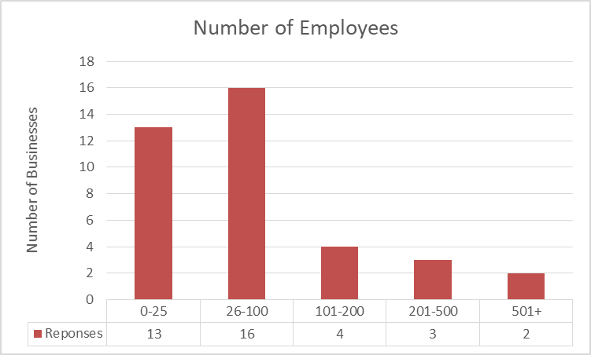

1. **How many jobs in Eddy County are currently unfilled?**

Some 77 percent of employers have full-time jobs available for a total of 289 unfilled positions. About 27 percent have part time jobs available for a total of 53 unfilled positions.

1. **How many additional employees do you anticipate hiring over the next five years?**

Around 40 percent of employers plan to hire between 1-10 people over the next five years. About 18 percent of employers expect to hire more than 25 people and another 21 percent expect to hire between 10 and 25. Of the 39 employers surveyed about 18 percent expect no change to staffing.

1. **Do you offer housing for any of your employees?**

Five of the employers offer housing for one to three of their employees. One explained it was temporary short-term furnished apartments only.

1. **Please estimate the percent of your employees that live in the following geographic areas.**

By far the largest number of employees (3,133 or 82 percent) live in the Carlsbad service area. Around 14 percent live outside of the Carlsbad service area—Artesia, Roswell, Hobbs. About four percent live as far away as Texas.

1. **In your opinion, is there currently enough suitable housing in the Carlsbad service area?**

Out of all employers surveyed, more than 80 percent responded “No” when asked and only seven employers indicated that there is currently enough suitable housing for their employees.

1. **Is this a factor affecting your employees?**

According to 64 percent of employers, the lack of suitable housing was a factor affecting their employees. Around 36 percent responded “no”, that they did not feel their employees were affected by it, but several of those indicated that while it was not necessarily a problem for their organization it was a problem they noticed in other businesses.

1. **Please estimate the percentage of your employees that need the following housing types.**

Some of the respondents interpreted this question to refer to the immediate needs of employees. Of these 15 employers, nine said a total of 138 needed long-term rentals, and four said a total of 38 needed homes to purchase.

The other segment of 24 respondents interpreted the question to mean their entire current workforce regardless if they currently had an acceptable living situation. Of those respondents who interpreted the question to mean their entire workforce, four said that 1% to 50% needed short term rentals, eight said 26% to 50% of their employees needed long-term rentals, and 15 said from 26% to 100% of their employees needed homes to purchase.

Short-term rentals were some of the least requested, but the majority of those who did request it fell into the category of construction/trades and healthcare services. Those needing long-term rentals spanned all sectors but were concentrated in mining/oil & gas, construction/trades, banking/finance/insurance, and government. Employees needing homes to purchase also were employed in all sectors but had highest need in the government sector.



1. **How would you characterize the experience your employees finding housing the Carlsbad area?**

When asked to characterize the experience of their employees finding housing in the Carlsbad area, more than 82 percent reported that this is “difficult” (57%), “very difficult” (20%), or “lack of housing is making it difficult to recruit employees” (5%) for their employees to find housing the Carlsbad area. Only six considered this process “easy” and none responded that the process was “very easy”. The most commonly cited reasons for the difficulties were that rental and for-sale housing was unaffordable and limited, and that what was available was not worth the market pricing, a sign that this market has a much higher demand than supply.

**Quotes and reasons cited for describing the search for housing as difficult:**

* “The difficulty our employees are running into is the cost being high. Most of our employees are looking for homes to purchase. We are looking to hire 5-7 more employees to replace spots that are vacated to due promotions etc. There has been some difficulty in the price and availability of homes and having to settle for an apartment. There is some apartments and subdivision coming soon that should help.”
* “cost & availability”
* “We need more lower income houses to rent/and or buy.”
* “$”
* “Employees are finding the cost of housing to be too high or availability to be limited. Employees have made me aware the housing in Carlsbad is hard to find. A lot of the time the homes or apartments are not what they are for and rent is atrociously high for what it is worth. Many of my employees find it easier to live with family than search for appropriate housing.”
* “All of the employees here are local and have established housing. This is not really an issue for me. Although I do see a need for more housing as the area grows.”
* “Good price.”
* “Lack of availability and cost”
* “Newer housing mid level”
* “Our prospective employees are having difficulty finding housing as rates that they are willing to pay.”
* “All of NCKRI's current employees have been in Carlsbad for a few years and are not looking for housing. As a result, I don't have any recent experience with the ease or difficult of finding housing currently in Carlsbad. A few years ago I heard many complaint in general from the community, but I have heard much recently. However, I've been traveling more over the past couple of years and I'm not connecting as much with the community so if there are concerns I may not be around to hear them. As a result, I don't feel qualified to answer some of the above questions and left them blank.”
* “Expensive”
* “oil and gas spin-offs”
* “Not enough available, what is available is too expensive. Most employees live in trailers or RV's but even to rent those spaces are expensive.”
* “Because of the price and their budgets. Had an employee move away to Vegas because housing wasn't affordable.”
* “cost of housing”
* “Our employees don't have problems but we work every day with people who do.”
* “Shortage and cost. It has gotten better with the apartments being built. We have not had a lot of out of town applicants applying, but those that come in are finding housing a little easier than 2 years ago.”
* “Availability and affordability compared to other areas where these folks have worked previously.”
* “Had a heavy equipment operator that came to Carlsbad after being hired, stayed in a hotel for a few weeks and then left because he couldn't find housing.”
* “Lack of housing, cost of housing”
* “With the addition of several apartment complexes and housing developments in recent years I have heard of no problems with employees finding a place to live whether they are renting or buying.”
* “But one person had an issue w/ affordability on a rental so they had to relocate to Hobbs for a while. It's an affordability issue, our employees haven't been really affected by it but I know it's an issue for Carlsbad.”
* “Unless we intervene on their behalf, there is no affordable rental property in Carlsbad. Families are the most difficult. We may try to pair up singles to share apartment living if appropriate.”
* “more affordable options - especially for rental”
* “Cost of housing even rentals are prohibitive.”
* “There are not enough affordable rents. Caring Angels is a state funded program so there are caps on what I can pay my employees, which means they are in the low income group of people. Some of my employees are homeless, I have 3 living in their cars.”
* “Our employees are paid at the low end of the local pay rate scale and cannot afford to rent a house or apartment. A lot of them decide to live two or more families together just to be able to afford the rent.” “There are no affordable rentals”
* “There is not enough affordable choices. My highest paid journeyman electricians make around $60k but I have lost 2 journeymen because they could not find affordable options. They moved here and then left.”
* “too expensive: not enough money for the value offered”

1. ***Future Development***

All of this information together portrays an area with a tight housing market and few rental vacancies at any price. Some people in the area are reluctant to purchase homes in the area believing the prices are too high for the available product or because they worry the growing oil and gas industry presence might end and they will go upside down on a high mortgage. A report from the City Planner says these are the newest projects to be expected in Carlsbad.

**Northern Carlsbad**

* **Copperstone Estates Subdivision**: Houses are being built. A total of 70 new lots for single-family housing. Homes will start at $320k. Construction continues. 15-20 lots are still available.
* **Fountain Hills Subdivision Unit 12**: located at the corner of Miehls Dr. and W. Church St. Unit 12 will create 10 new 1 + acre lots for residential development. The preliminary plat and plans have been reviewed and approved by the Planning and Zoning Commission. The developer is Ken Thurston. Construction should begin soon.
* **Fountain Hills Subdivision Unit 18**: Approved by the Planning and Zoning Commission. This development will create 17 new lots for single-family housing. Initial construction of the lots and primary infrastructure continues.
* **Freedom Way Subdivision**: The Planning and Zoning Commission have approved this development and construction on the development is complete. Houses are now being built. This development created 13 new lots for single-family housing near McKay and Elm St. Six new homes have been built in this development, and a seventh home is under construction.
* **Spring Hollow Subdivision, Unit 2, Phase 1**: Located north of Ligon Rd., north of Spring Hollow Subdivision Unit 1. This is new construction, single-family homes. 76 new lots were created for single-family homes. About 60 of units have been built. About 8-10 lots are still available for this subdivision.
* **Pecos Vista Apartments**: Broke ground on April 21, 2017. Construction nearing completion for 196 market rate units. Eight units were dropped from the original permit that was pulled. Construction continues. Preliminary estimation of a completion date is set for mid-February 2018.
* **Colonial Hillcrest Apartment rehabilitation**: This project is under construction now. No new units will be created, will be a rehab of the existing units. Estimated date of completion should be shortly after the first of the year.

**Southern Carlsbad**

* **Farmview Subdivision Phase 5**: located at the corner of Elgin Rd. and Cowboy Country Rd. This phase will create 14 new ¼ acre lots for residential development. The preliminary plat and plans have been submitted for consideration at the Dec. 4, 2017, Planning and Zoning Commission. The developer is Ken Thurston. The property owner is Walterscheid Trucking and Farms Inc.
* **Martin Farms Subdivision Unit 1**: Scheduled to be heard by the Planning and Zoning Commission in August 2017. This development will create 33 new lots for single-family housing. Unit 1 is part of a larger master plan for Martin Farms. Preliminary plans indicate that approximately 300 new lots will be created and installed in the subsequent units. Located off Old Cavern Hwy and Farris St. Unit 1 preliminary plat and construction plans were approved by the Planning and Zoning Commission at the August 7, 2017, meeting. Construction has begun. The initial construction of the lots and primary infrastructure is nearing 75% completion.
* **Sunwest Subdivision Unit 7**: Scheduled to appear before the Planning and Zoning Commission in August 2017. This development will create 55 new lots for single-family housing. Modular, pre-fab homes. The preliminary plat and plans were approved by the Planning and Zoning Commission at the Special Meeting on Friday, August 18, 2017. Initial construction on the lots and primary infrastructure for this project has begun.
* **Montclair Development**: the Planning and Zoning Commission as well as City Council have approved this development. It is combination of residential, commercial, and industrial developments. When building begins there will accommodation for approximately 2,800 single-family dwelling units and 1,200 multifamily units. Montclair will be beginning with industrial land development over the first 1-3 years. The development agreement was presented to the City Council at the November 21, 2017, Special Meeting, and the Council voted to approve the agreement. The developer now needs to file the annexation plat, Ordinance, and development agreement with the County Clerk.

The table below is a numerical representation of the report provided by the Carlsbad City Planner so there may be some overlap between current building report data and future building permits to be pulled.

The planning and zoning commission approved the majority of these projects and they are now in the construction phase adding 484 units of housing. An additional 4,300 units are in discussion but will still have a series of steps to take before construction begins. If completed, the deficit of needed housing could be reduced from an estimate of 6,532-7,072 to an estimate of 1,748-2,288. However, based off the fact that Carlsbad has added 2,116 housing units over a seven-year period, building 4,784 within the next two years seems unlikely. The proposed total number is also conditional based on the ability to recruit builders to projects such as Montclair, which has put around 4,000 units, both single-family and multi-family units, into their PUD, but will still need assistance in recruiting builders.

**Table 6. Future Residential Development Qtr 2-Qtr 3 2017**

|  |  |  |  |  |  |
| --- | --- | --- | --- | --- | --- |
| Residential Units | Manufactured Housing/Mobile Homes | Total Single Family | No. of Apt Units | Duplex Units | Total Housing Units |
| **Plats Approved by Planning & Zoning Commission or In Construction Phase** | 55 | 233 | 196 | 0 | 484 |
| **Future Plans Not Yet Approved** | 0 | 3,100 | 1,200 | 0 | 4,300 |
| **Total Units to Be Created** | 55 | 3,333 | 1,396 | 0 | 4,784 |

Source: City of Carlsbad 2017

1. ***Conclusion***

After evaluating the current data, we can conclude:

* The rise in temporary workers has filled up apartments, hotels/motels, RV camps, which pushes rent and housing prices higher.
* Employers are having difficult filling jobs due to the lack of housing available and its high costs.
* Despite the addition of 2,116 housing units since 2010, rental vacancy rates are at 90-100% occupied.
* Average rents for more than 75 percent of the apartment units in Carlsbad in 2017 were $900 for a one-bedroom, $1,172 for a two-bedroom, and $1,329 for a three bedroom. These are unaffordable for households with income below 80 percent of AMI (area median income) without a subsidy.

While residential development has been ongoing in Carlsbad, it is likely that as the prosperity in the oil and gas industry continues, we will continue to need more housing, possibly even more than what the housing studies suggested. At the **minimum**, we need to recruit 1,000 additional units of housing of various types per year so long as the economy remains strong. The Carlsbad Department of Development must continue to concentrate on facilitating development in a range of housing choices that meet the diverse needs of our community’s citizens and businesses. Many have been wary about overbuilding due to fear an economic downturn affecting our extractive industries, but while no one can predict the future, given the ever-increasing reserves they are finding in the Delaware Basin, oil and gas companies expect their activity here to last up to 25 years.

For questions or comments:

Shannon Carr

Local Development Coordinator

Carlsbad Department of Development

[Shannon.carr@developcarlsbad.org](mailto:Shannon.carr@developcarlsbad.org)

(575) 887-6252